MICHIGAN STATE UNIVERSITY ADMINISTRATIVE PROFESSIONAL SUPERVISORS ASSOCIATION
Minutes of Semi-Annual Membership Meeting
Tuesday October 17, 2023
at MSUFCU Community Room, Farm Lane Branch East Lansing Michigan and
Via Microsoft Teams

CALL TO ORDER
President Garza called the Semi-annual membership meeting to order at 12:00 PM. We had 71 members attending in person and 156 APSA members attending virtually.

Executive Board Members Present (include virtual attendees): – Sean Barton, Randy Brown, Cheryl Berry, Melissa Del Rio, Kathleen Deneau, Ken Deneau, Joe Garza, Heather Hazzard, Aaron Minnis, Mike Ouderkirk, Mariano Porco, and Sheryl Soczek and James Terrill.

APSA Members excused – Karla Bauer and Sam Fortino.

Associate Member- Mike Gardner (virtual)

APSA Legal Counsel – Jeff Donahue

APPROVAL OF AGENDA

Agenda of October 17, 2023
Motion made by Vice President Ouderkirk to approve the agenda dated October 17, 2023; seconded by member Vice President Minnis, motion passes without dissent.

Minutes of April 17, 2023
Motion made by Director Barton to approve the agenda dated April 17, 2023; seconded by member Director Hazzard, motion passes without dissent.

OFFICER AND COMMITTEE REPORTS

President’s Report
President Garza presented his report with all members present. (See PowerPoint attachment)
Updates included:
- Represented those employed in APSA positions through their workplace issues. Increase in contacts from members.
- Wages for Fall 2023 will be 1.00%. This is the first cycle of our current Healthcare MOU- for Fall 2024 it will be 2% (the second cycle)
- Dues were kept at reduced amount for year 2023 to $10 a month, (the lowest on campus). The Executive Board has agreed to continue the new rate into July 2024.
- Secured a 3% General increase from MSU Board of Trustees for October 1, 2023.
- Signed LOA for three break days between Christmas and New Years to be considered holidays, so members required to work would receive Holiday pay.
- Signed LOA recognizing MLK as holiday for employees, those required to work will receive holiday pay.
- Signed LOA for two Observance days that are during the calendar year Jan-December.
- Currently serving on the Administrative Spend Efficacy Analysis Advisory Committee.
- Served on Staff Benefit Director Search Committee.
- Secured a new Dental Premium Plan for 2024.
- Secured new health plan options for out of state employees beginning in January 2024.

CBA Agreement Highlights:
- Began the Negotiation Process in January 2023. Team met multiple times to prepare proposal based on member survey and input/review of other union contracts and recent gains they were able to obtain. Requested bargaining to begin two months earlier than previous sessions (May). Did not get first bargaining date with the University until July 2023.
- University invoked PA 54 of 2011 that freezes certain benefits and wages if contract expires during bargaining. We asked for a contract extension to avoid this measure. PA54 has been repealed effect Feb/March 2024 by current state legislators and the Governor.
- Held Town Hall meeting to discuss impact to members on Tuesday, October 3, 2023.
- Requested that members send letters of disapproval for actions toward the Association to Interim President Woodruff, MSU Board of Trustee. EVP Melissa Woo and VP Christina Brogdon. University agreed to extend contract through October 31, 2023. Signed LOA.
- Will notify membership once a tentative agreement is reached and is approved by APSA Executive Board for ratification vote by membership.

Upcoming Agenda Items for this year:
- Continue to bargain with the University to reach a successor CBA
- Represent the Association at CLO/JHCC meetings with other bargaining units to address members needs and University changes. Continue to introduce cost savings/health care enhancements to our benefit programs.
- Conduct an APSA Board Retreat to plan out upcoming agenda items for the year.
- Will conduct an RFP process for legal counsel.

Vice President for Contract Administration – Mike Ouderkirk and Aaron Minnis
Vice Presidents reviewed common questions asked by members and reviewed several sections of the contract including:
- PROBATIONARY/TRIAL PERIOD PROBATIONARY PERIOD
- -168 Employees shall serve a twelve (12) month probationary period beginning at the time of hire as a new Employee with the University or upon initial entry into the bargaining unit from other University employment. The Unit Employer-supervisor shall have the right to certify successful conclusion of the probationary period before the end of the twelve (12) months. The Association President shall be notified upon early certification.
- -169 An interim written evaluation shall be prepared by the probationary Employee's supervisor, summarizing overall job performance, which shall be reviewed with the Employee. If a probationary Employee's performance is unsatisfactory, such fact shall be communicated to the Employee as soon as is practicable to give the Employee the opportunity, if possible, to improve their performance.
- -170 The Association shall represent probationary Employees for the purposes of collective bargaining with respect to rates of pay, wages, hours of employment and other conditions of employment; however, no matter concerning the discipline, layoff or termination of a probationary Employee shall be subject to the grievance or arbitration procedures.
- Counseling memorandum to be removed from personnel records no later than 18 months from issue date if performance is satisfactory
- Office of Institutional Equity meetings-all members have a right for representation regardless of if they are Claimant/Respondent/Witness
- Article 7 paragraph 62-64 employee has the right to representation, being informed of subject matter prior to any interviews, being entitled to a pre-interview conference with a union representative.
As a reminder APSA has two Vice Presidents that are available to our membership
- Need Representation go to the web site at www.msuapsa.org and click on the I need representation link for contact information
    - When should you request representation? If you receive a request from your supervisor or human resources team for a meeting, you should request representation.
- Vice Presidents for Contract Administration are always available to assist!!
  - Vice Presidents are currently offering meetings via Zoom, Teams and Telephone calls or in person.

Treasurer’s Report –Ken Deneau
Treasurer Deneau reviewed APSA financial status with the members present. Treasurer noted that the Association is financially strong.
- Reviewed FY2023 versus FY2022 revenue and expense report
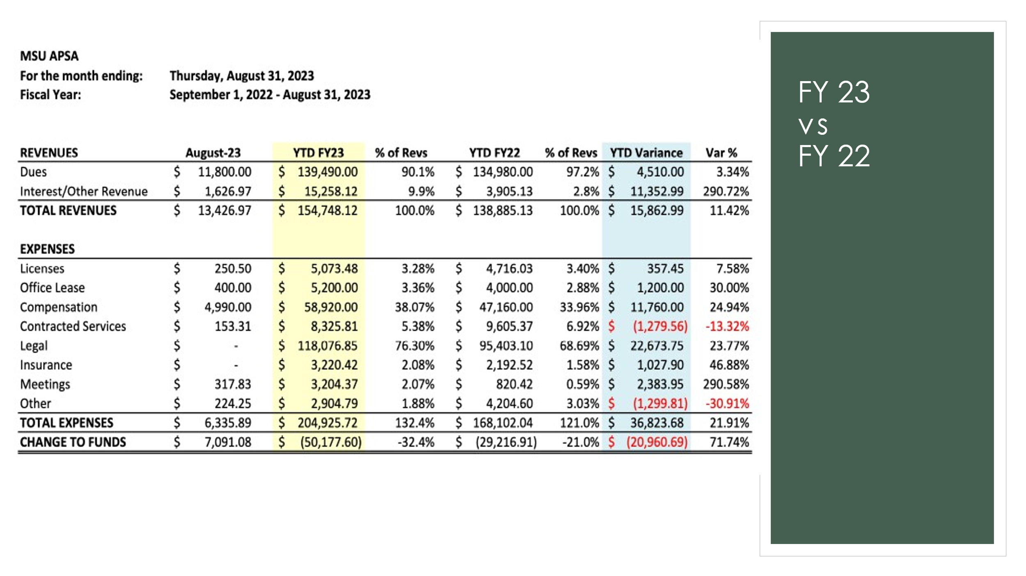
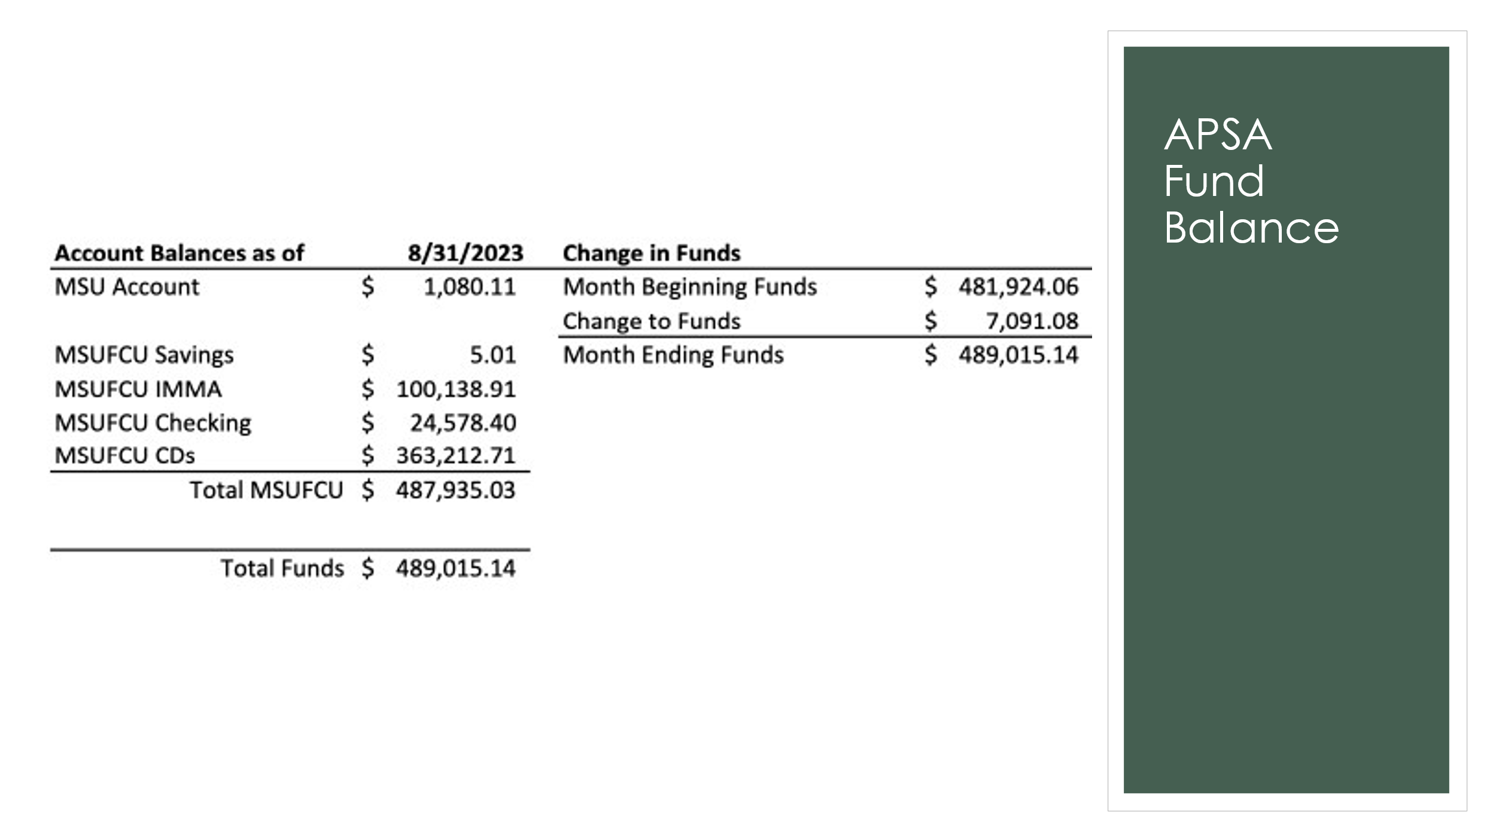

Recording Secretary – Kathleen Deneau
- Recording Secretary mentioned that all minutes can be found on the APSA website at APSA Minutes
- Open Enrollment:
  - Please remember to complete your Open enrollment by October 31, 2023.

Report of the Corresponding Secretary – Randy Brown
Corresponding Secretary reviewed the following:
Membership Participation Metrics:
- 532 October 3, 2023, Virtual Town Hall
- 212 October 17, 2022, Hybrid Semi-Annual
  - 82 in-person members
  - 130 online members
- 492 Votes were cast in April 2023 vote
** Participation is strong in APSA **

Communication Metrics:
- 16 mass communications with membership in the past year
- 668 direct communications with membership in the past year
- 143 email inquiries from the membership in the past year
** Hint; most of my communications begin with “Your…” **

Report of the Membership Secretary- Karla Bauer _absent)
Twelve Year Summary (January)
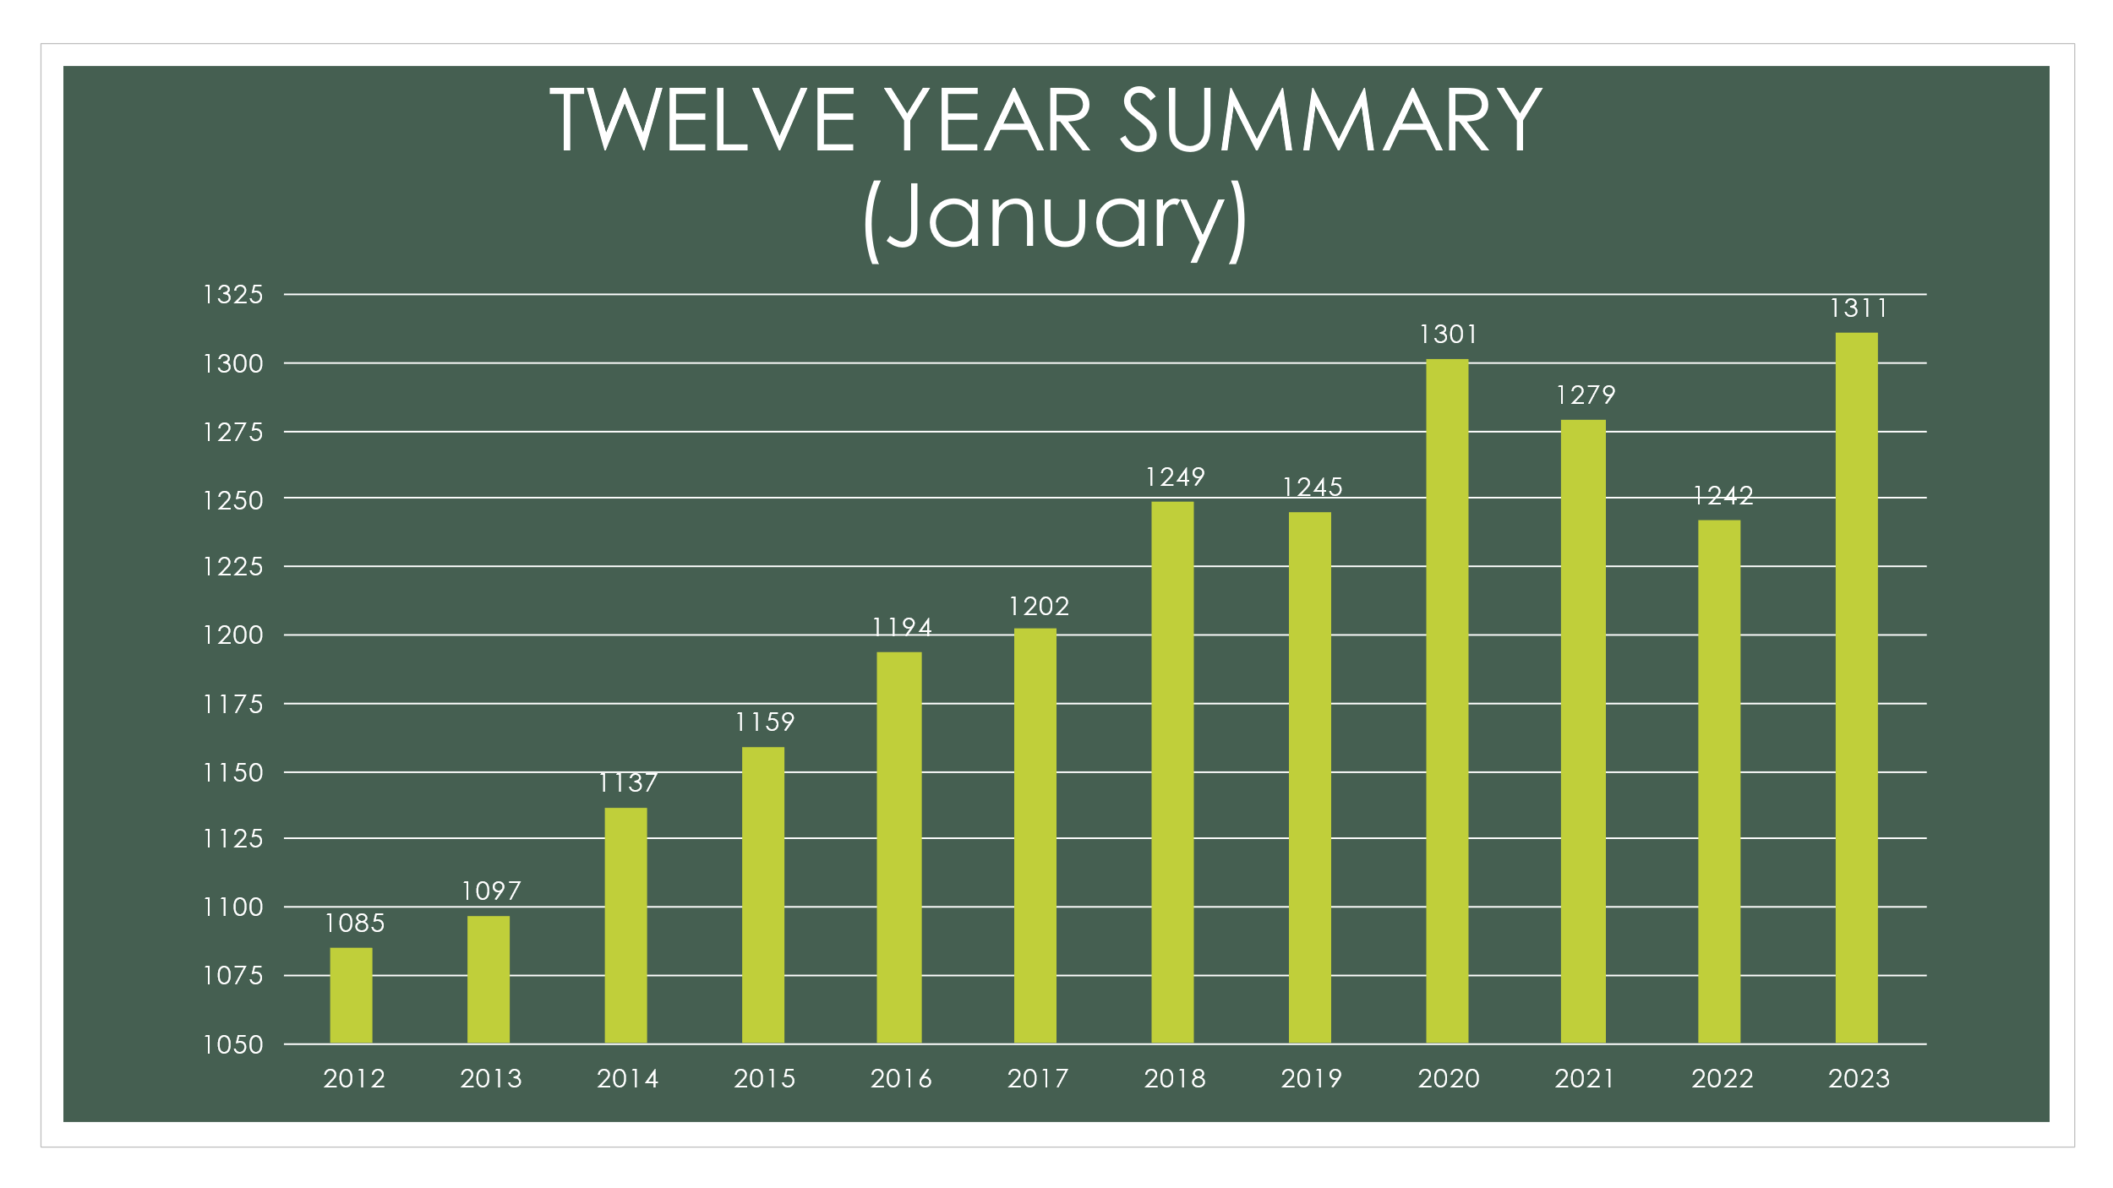

APSA Roster Last Six Months
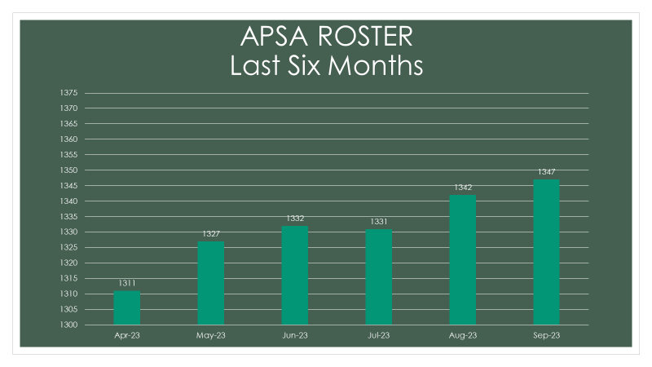

Motion made by Director Hazzard to accept the APSA officer’s and committee reports ; seconded by Director Barton; motion passes without dissent.

Member’s Privilege –
Questions from members:
- Question about extension of current contract and intention of the university by not originally agreeing to extend our current contract.
  - APSA legal Counsel Donahue explained that he felt the decision was misguided versus malicious.
- Question about new premium dental plan – President Garza directed members to visit the HR website at https://hr.msu.edu/benefits/dental/index.html
- Member inquired about optional life insurance costs offered through the university versus alternative coverage offered from other companies.
  - Recording Secretary Deneau encouraged members to price check for similar coverage offered from other life insurance companies instead of trusting that costs are compensative via Prudential (MSU’s life insurance policy option.) Recording Secretary Deneau noted that she found significant cost savings with guarantee monthly premium lock in rates offered by Lincoln Financial, Pacific Life, and Banner life insurance companies. The optional employee paid plan offered through Prudential includes rate increases based on your age and limited coverage after the age of 70.
- Member asked question about medical costs and how we can keep them reasonable. President Garza explained that he continues to actively review all medical costs on a regular basis with the goal of leveraging any discounts or savings available.
- Member inquired about level 12 supervisors and specifically those that are required to be on standby in case they are needed to work. President Garza noted he is aware of this concern and continues to address with the university.
- Question from member regarding the medical benefits offered to APSA members who reside outside of Michigan and specifically if this benefit could be negatively impacting our overall health care costs which are directly tied to our potential for raises. President Garza assured the member that this is not negatively impacting future raises.

Standing Committee Reports

Bylaws Committee: no report

Business Committee: no report

Grievance Committee: no report

PACDI: no report

Member outreach committee: no report

Employee Assistance Program: no report

All-University Traffic Committee – Director Barton provided an update to membership about his role as Chair of the AUTC and offered to advocate on behalf of concerns from our membership.

Other Committees: no report

NEW BUSINESS
- None

UNFINISHED BUSINESS
- President Garza reviewed timeline and next steps once we have a tentative agreement with the university including having members vote to accept it.
- President Garza will ask for another extension to our contract if there has not been a tentative agreement reached by October 27, 2023 (next negotiations meeting scheduled with the university.)

ADJOURNMENT
MOTION by Director Barton to adjourn; motion seconded by Director Hazzard and was approved with no dissent. Meeting adjourned at 1:03 p.m.

Meeting minutes respectfully recorded by Kathleen Deneau, APSA Recording Secretary.

